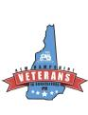
New Hampshire Farm Bureau

Veterans in Agriculture

Meeting Agenda

September 13, 2017

0800 conference call

Connect information:
Section 15. The Chairman of the New Hampshire Farm Bureau Veterans Committee shall be responsible for presenting for approval to the state board of directors an annual plan of work and budget for use of Farm Bureau funds.
The Chairman of the New Hampshire Farm Bureau Veterans Committee shall also report to the board of directors’ program accomplishments and fiscal status on an annual basis.
Mission Statement: “Recruit, Educate, Support, and Promote Veterans and their Families in Agriculture.”

Call to Order: Chairman Putnam

Attendance

Chairman’s Report
Abdali farms Langdon write up
https://extension.unh.edu/Agriculture/Coos-County-Ag-North-Country-Updates

Secretary’s report
- Accept minutes from last meeting
- Tracker and collection of events
- Agendas drafts 1 week before meeting, final 24 hours before meeting
- Reports due to group draft 3 days, final report when accepted at next meeting.
- Due outs next 30 days
- Note taking and preparedness

Old business
- New England Veterans in Agriculture Resources this program is run and managed by Derek Heins hand out was presented to all at this meeting follow up on phone meeting 13 September 2017
- Steve Turaj Hi Diane,
Mike and I have been in touch with Gary LaGrange and will probably have him come to NH to talk in May. Can you arrange to show this brief video at our meeting?
https://www.flatlandkc.org/people-places/veterans/veterans-training-farm/
Thanks,
Steve

Other Business
- Product ECommerce https://www.vets2farm.org/our-store this project may be an added selling point for membership and drive the concept Veterans are a member of FB and NHFBVA Associates can join 50.00 Relative of a vet and associates all others 100.00. As these other grow that are close to FB and may be a pipeline for membership them self’s.

- Facebook page for Veterans in Ag
- Branding, Logos and use
Derek Hines
I can get these printed at $4/10. Bumper stickers are more, but if we offer these to our veteran members, I bet they would identify themselves pretty quickly. It is a 3.5 x 2” vinyl sticker for windows. Car, stores, whatever.

Just an idea.

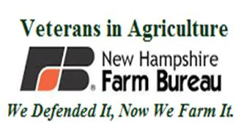

Derek Hines
I’ve looped Glen in on this discussion. I really like the idea of specific branding for the committee. My suggestion is that we utilize the snazzy looking logo that has been developed once it is finalized and cleared by Glen (see attached). The motto down below is great.

I’m also going to look back at the cost for our window stickers for NHFB 100 year celebration and compare pricing.

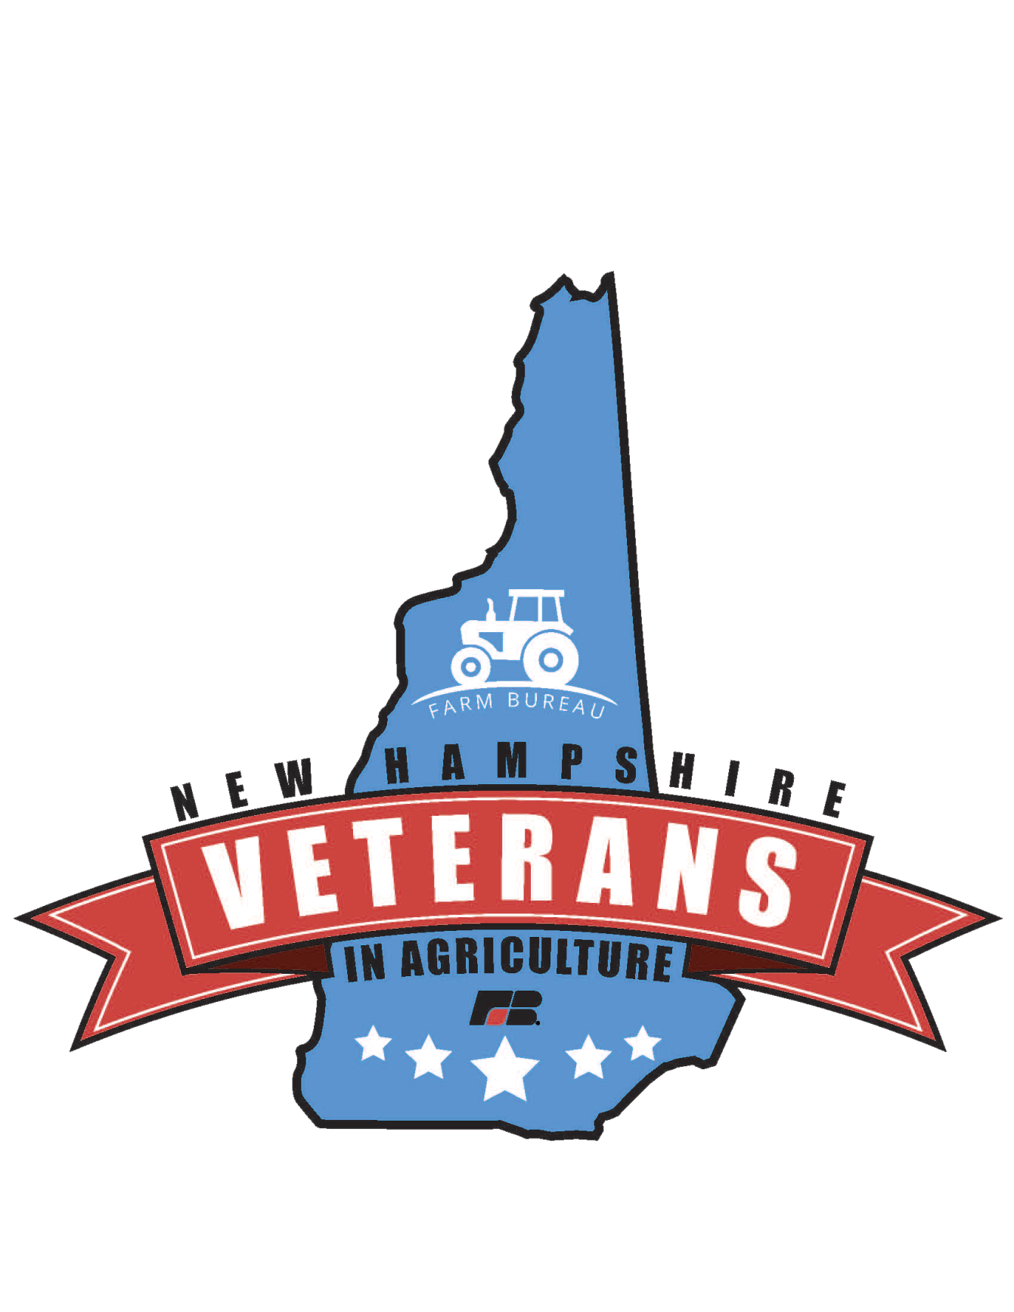
Adjournment

